**COMP9032 Project – User Manual**

# **What come’s with the package**

* AVR lab board x 1
* Wires x 10
* User’s manual x1

# **Tutorial before flying**

## 1. How to wire up AVR lab board

* All jumper wires should be connected already on the AVR lab board.
* Alternatively, please remove all the connected jumper wires on the AVR lab board and follow the instruction in Appendix 1. for detail wiring.

## 2. Keypad

- The keypad will the main control system during take-off, flying and landing operation.

Following is the detail actions for both manual mode and auto mode while a key is pressed

|  |  |  |
| --- | --- | --- |
| Key | Manual Mode | Auto Mode |
| 0 | N/A | value 0 on LCD |
| 1 | Moving Upward - U | value 1 on LCD |
| 2 | Moving forward - F | value 2 on LCD |
| 3 | Moving downward - D | value 3 on LCD |
| 4 | Rotate to right - R | value 4 on LCD |
| 5 | N/A | value 5 on LCD |
| 6 | Rotate to left - L | value 6 on LCD |
| 7 | N/A | value 7 on LCD |
| 8 | N/A | value 8 on LCD |
| 9 | N/A | value 9 on LCD |
| A | Switch to Auto Mode | N/A |
| B | N/A | confirm Input |
| C | Increase speed by 1 | N/A |
| D | Decrease speed by 1 | N/A |
| * | Hovering/resume previous position - H | N/A |
| # | Take off/ landing | N/A |

* please refer to appendix 2 for key-action illustration

## 3. LCD

The LCD display is used to display various of information during the flight

* Instruction for take-off in manual mode
* Set destination and speed
* Position, direction, compass and speed during flight
* Flight duration and distance after landing
* Crashed position and speed once it reaches boundary

3.1 Before take-off

Start (M mode):

|  |  |  |  |  |  |  |  |  |  |  |  |  |  |  |  |
| --- | --- | --- | --- | --- | --- | --- | --- | --- | --- | --- | --- | --- | --- | --- | --- |
| S | t | a | r | t | : | ( | M | ) |  |  |  |  |  |  |  |
| K | e | y |  | B |  | t | o |  | C | o | n | f | i | r | m |

* Once the program is started or reset, above message will be displayed as default.
* **Press key B** to confirm current mode

Start (Auto mode):

|  |  |  |  |  |  |  |  |  |  |  |  |  |  |  |  |
| --- | --- | --- | --- | --- | --- | --- | --- | --- | --- | --- | --- | --- | --- | --- | --- |
| S | t | a | r | t | : | ( | A | ) |  |  |  |  |  |  |  |
| K | e | y |  | B |  | t | o |  | C | o | n | f | i | r | m |

* **Press key A** on the keypad to switch to Auto mode.
* **Press key A** again to switch back to manual mode.
* **Press key B** to confirm current mode.

Before take-off (M mode selected):

|  |  |  |  |  |  |  |  |  |  |  |  |  |  |  |  |
| --- | --- | --- | --- | --- | --- | --- | --- | --- | --- | --- | --- | --- | --- | --- | --- |
| M |  | m | o | d | e |  | s | e | l | e | c | t | e | d |  |
| K | e | y |  | # |  | t | o |  | C | o | n | f | i | r | m |

* When M mode is selected, **press key #** to perform taking-off action

Before take-off (Insert destination and flying speed)

|  |  |  |  |  |  |  |  |  |  |  |  |  |  |  |  |
| --- | --- | --- | --- | --- | --- | --- | --- | --- | --- | --- | --- | --- | --- | --- | --- |
|  | X |  |  |  | Y |  |  | Z |  |  | S | p | e | e | d |
| 4 | 0 | , |  | 4 | 0 | , |  | 8 | , |  | 1 | m | / | s |  |

* When A mode is selected, insert numerical value from keypad to set up destination.
* **Press key B** to confirm input destination at anytime

## 3.2 During flying

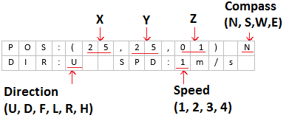

* In M mode, flying direction and speed can be amended from keypad
* **Press numerical value** from keypad to change flight direction:
* **Press key C or key D** to change speed
* **Press key** * to perform hovering
* **Press key #** to perform landing

## 3.3 End of flight

Successful landed

|  |  |  |  |  |  |  |  |  |  |  |  |  |  |  |  |
| --- | --- | --- | --- | --- | --- | --- | --- | --- | --- | --- | --- | --- | --- | --- | --- |
| D | i | s | t | a | n | c | e | : | 4 | 6 | m |  |  |  |  |
| D | u | r | a | t | i | o | n | : | 1 | 4 | s |  |  |  |  |

* Motor stop spinning,
* total distance and flying time

End of flight (Crashed)

|  |  |  |  |  |  |  |  |  |  |  |  |  |  |  |  |
| --- | --- | --- | --- | --- | --- | --- | --- | --- | --- | --- | --- | --- | --- | --- | --- |
| P | O | S | : | ( | 1 | 9 | , | - | 2 | , | 0 | 3 | ) |  | N |
| D | I | R | : | F |  |  | S | P | D | : | 3 | m | / | s |  |

* Motor stop spinning
* Crashed position, direction and speed
* Full LED bar flash on and off continuously

## 4. Motor

The motor has 4 spinning speed:

* Slow spinning when speed is 1m/s
* Median spinning when speed is 2m/s
* High spinning when speed is 3m/s
* Max spinning when speed is 4m/s

The motor remains non-spinning in setup, landed or crashed phases

## 5. Constraints

**Constraints**

* Start position (x = 25, y = 25, z = 0) where x is length, y is width, z is height

|  |  |  |
| --- | --- | --- |
| Accessible area: | Min (meter) | Max (meters) |
| X (length) | 1 | 49 |
| Y (width) | 1 | 49 |
| Z (height) | 1 | 9 |

* Auto mode need to be set before flight
* Speed range: 1m/s, 2m/s, 3m/s and 4m/s

# **Scenario:**

Scenario 1: Successful flight

1. Take off
2. Flight with direction and speed
3. Reach destination
4. Landing, Z = 0

Scenario 2: Crash

1. Hit vertical walls (X >= 50 or X <= 0) or horizontal walls (Y >= 50 or Y <= 0)
2. Hit Ceiling Y >= 10

Scenario 3: Rotation

1. During flying, if R or L key is pressed, UAV will change its direction to either R or L regard to the corresponding has been pressed.
2. Position will remain the same but compass will be updated in each second with 90 degree rotation.

Scenario 4: Hovering

# **Operation Flowchart**

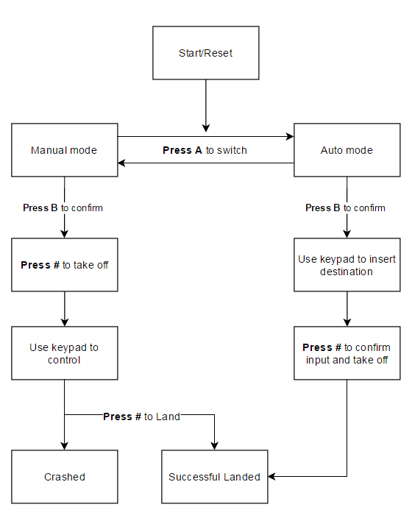

1. **Manual Mode**

Press key to take off

* Take off, raising height at 1m/s

Controlling

* Taking Off
* Changing flight direction
* Changing the speed
* Hovering
* Landing

LCD Display

* Start
* Flying
* End of the flight
* Crash

LED

* Crash



1. **Auto Mode**

Input

* Press A key to switch to Auto mode before flight
* Destination: insert number on keypad with format ##*##*#* #B
* Press * key to act as separator
* Press B key to confirm

Valid input:

X is in range of 01-49

Y is in range of 01-49

Z is in range of 1-9

Speed is in range of 1-4

Invalid input

* If no value has been inserted or incomplete input, press B will execute the default destination (40, 40, 8) with speed 1m/s
* Height
* Speed
* Mode

LCD Display

* Default and user input
* Start
* Flying
* Destination

Appendix

1. Wiring

|  |  |  |  |
| --- | --- | --- | --- |
| Port Group | Pin | PortGroup | Pin |
| PORT F | PF0 | LCD DATA | D0 |
| PORT F | PF1 | LCD DATA | D1 |
| PORT F | PF2 | LCD DATA | D2 |
| PORT F | PF3 | LCD DATA | D3 |
| PORT F | PF4 | LCD DATA | D4 |
| PORT F | PF5 | LCD DATA | D5 |
| PORT F | PF6 | LCD DATA | D6 |
| PORT F | PF7 | LCD DATA | D7 |
| PORT E | PE5 | LCD CTRL | BL |
| PORT A | PA4 | LCD CTRL | BE |
| PORT A | PA5 | LCD CTRL | RW |
| PORT A | PA6 | LCD CTRL | E |
| PORT A | PA7 | LCD CTRL | RS |
| PORT C | PC0 | LED BAR | LED2 |
| PORT C | PC1 | LED BAR | LED3 |
| PORT C | PC2 | LED BAR | LED4 |
| PORT C | PC3 | LED BAR | LED5 |
| PORT C | PC4 | LED BAR | LED6 |
| PORT C | PC5 | LED BAR | LED7 |
| PORT C | PC6 | LED BAR | LED8 |
| PORT C | PC7 | LED BAR | LED9 |
| PORT K | PK15 | KEYPAD | C3 |
| PORT K | PK14 | KEYPAD | C2 |
| PORT K | PK13 | KEYPAD | C1 |
| PORT K | PK12 | KEYPAD | C0 |
| PORT K | PK11 | KEYPAD | R3 |
| PORT K | PK10 | KEYPAD | R2 |
| PORT K | PK9 | KEYPAD | R1 |
| PORT K | PK8 | KEYPAD | R0 |
| PORT L | PL4 | MOTOR | JP91 |
| N/A* | POT | MOTOR | Mot |

* Remove cap of JP91 and use jumper wire to connect Potential meter with the Motor to prevent large current been drawn through the motor to cause damage

2. Keypad - event illustration

